

**Key Stage 4**

**Parent Handbook**

**2024-2025**

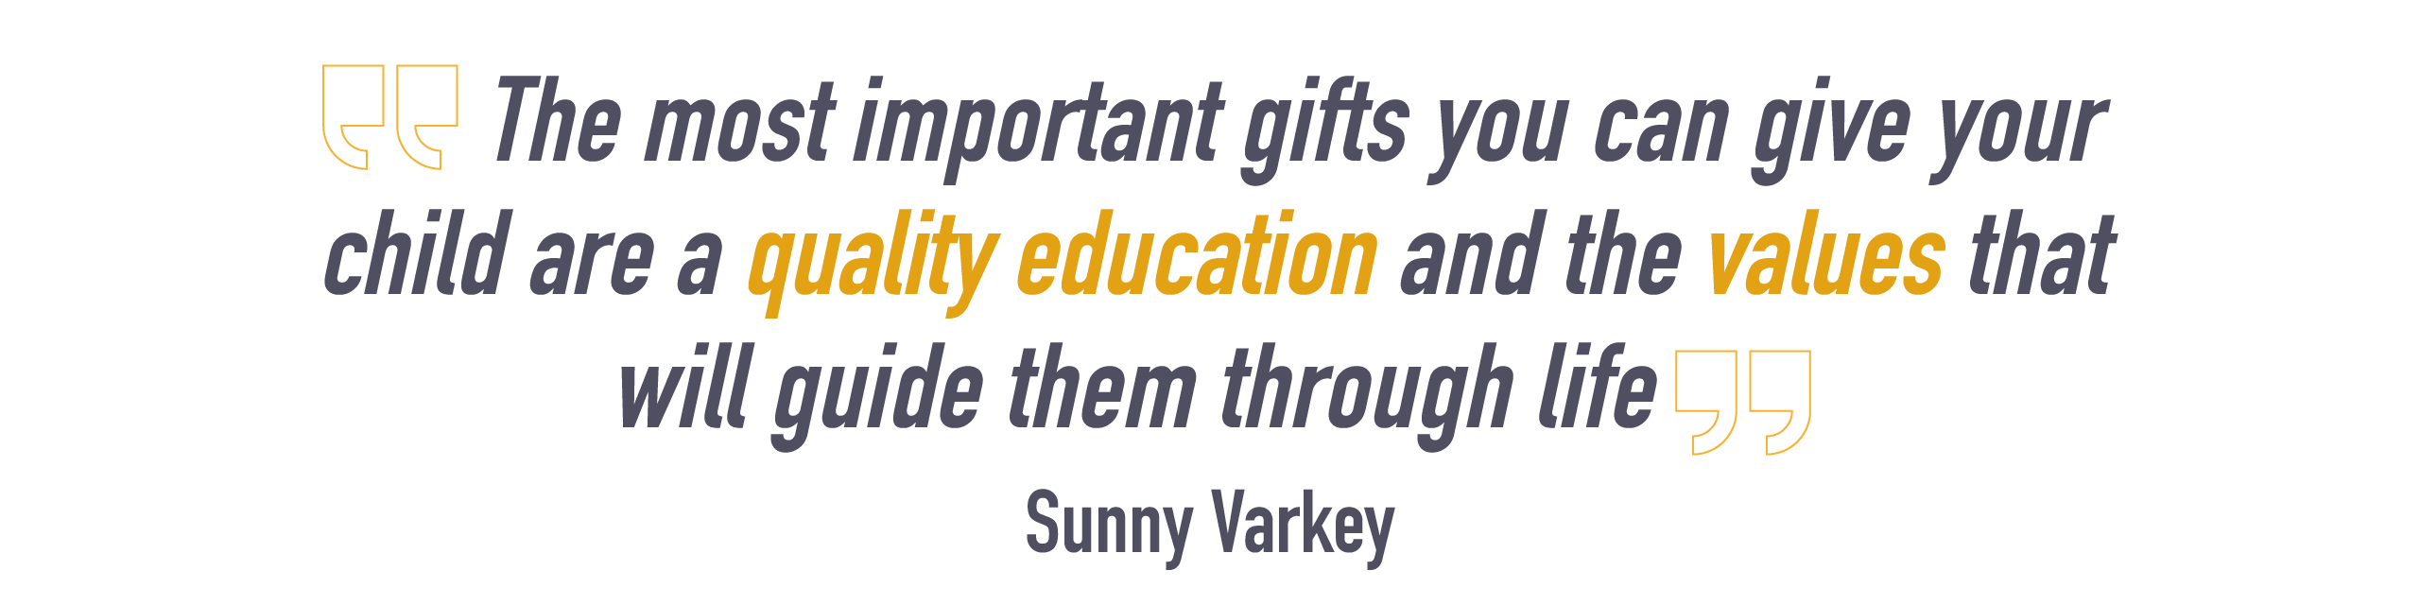



Contents

School Contact Details

Welcome to the Secondary Section of The British International School Madinaty 3

Vision and Goals

School Calendar

The School Day, Attendance and Punctuality 4

Essential Classroom Equipment 5

Before School and at Break and Lunchtime - Where should I be? 6

The Student Diary 7

Our Positive Achievement Strategy 8

Assessment

Extra-Curricular Activities 15

The House System 15

Driving motorised vehicles to school 15

Behaviour on School Buses 16

Bullying 17

The British International School Uniform 19

Who should parents contact in the secondary school? 20

Parent/Student agreement

Study skills 20

links to the curriculum 22

Curriculum map

# 

|  |
| --- |
| **School Contact Details** |
| Address: The British International School  Talaat Moustafa Road,  Madinaty City,  Suez Road,  Cairo,  19511  Egypt  Telephone: +201022230013/14/15/16  Website: [www.bism-cairo.com](http://www.bism-cairo.com)  Email: frontdesk_bim@gemsedu.com  Facebook: facebook.com/BISMCairo |

# Welcome to the Secondary Section of The British International School Madinaty

Dear Students and Parents,

This booklet and the information it contains is designed to ensure that your child has every opportunity to make a smooth transition from key stage 3 to key stage 4. It acts as a guide to how the school operates during Key Stage 4 (Years 9 and 10) and how your child can benefit from the high quality British education we offer.

In the first section you will find lots of useful information, ranging from the timings of the school day to who to contact if you have a need to discuss a particular issue. Please take the time to read through this and discuss it with your child. Look after this booklet as you may need to refer to it at various times during your child’s time with us!

In the second section you will find information on the curriculum and options your child will study in Key Stage 4, along with links to the external examination boards.

You have chosen The British International School because of our particular model of education, taught through the medium of the English Language. To ensure that your child is able to benefit from their opportunities here, we insist that only English is spoken in school. (The obvious exceptions will be when students are speaking to an Arabic teacher or speaking the target language in French.) Students need to develop their subject vocabulary and clear diction by speaking English as much as possible both in school, with their teachers and peers, and at home. We depend upon the partnership between school and home to work towards our shared goal of fluency and accuracy in English. This is a highly desirable life skill which should also lead to easy comprehension of examination questions and the ability to answer in good English as the Examination Boards demand. In this way, students should achieve their true academic potential in the British examinations.

We at The British International School Madinaty regularly review and update our procedures and methods to ensure every child attains the best they can. We believe that education demands a partnership between home and school and we are happy to receive any suggestions from parents or students about what should be included in this booklet.

We look forward to working with you all and wish your sons and daughters every success in their endeavours here at The British International School.

Ms. Janet Brock

Principal

# Our Vision and Mission

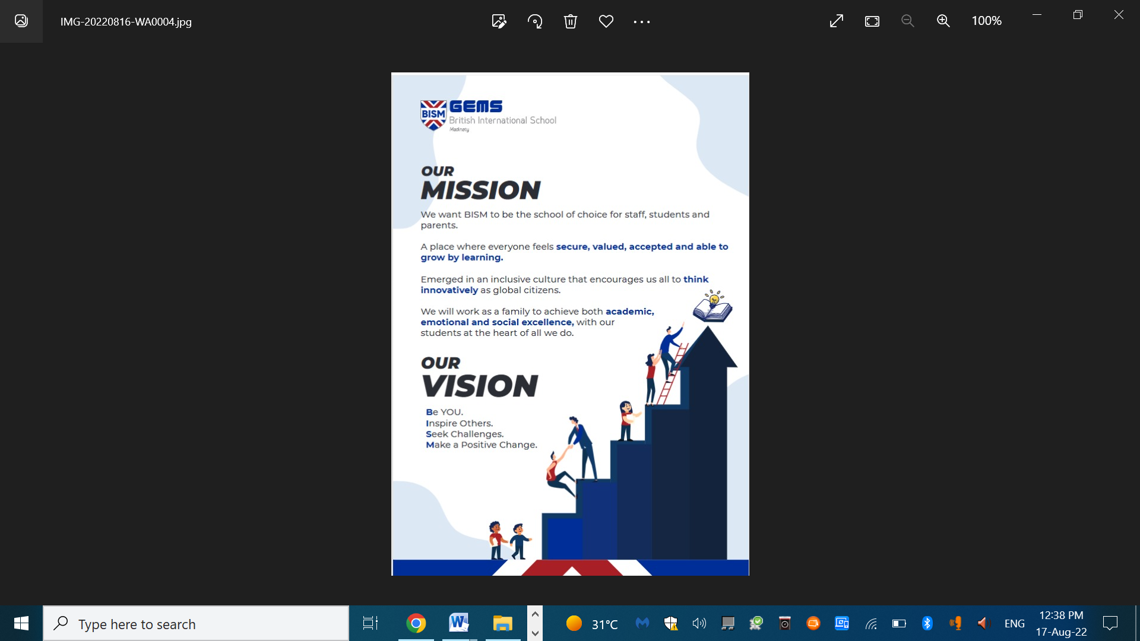

**Our Values**

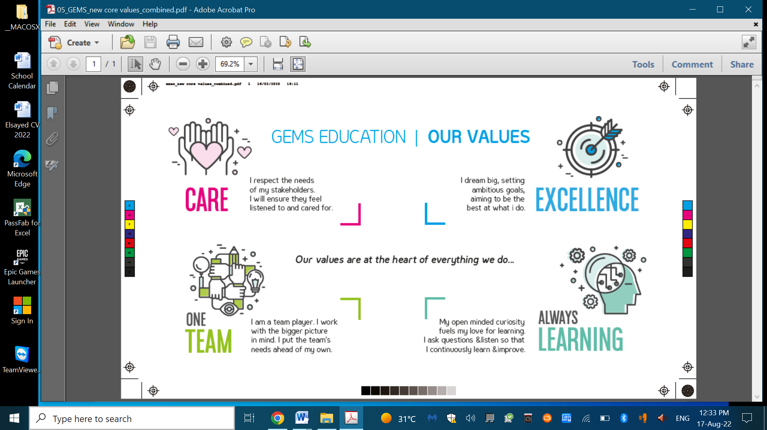

**School Calendar 2024-2025**

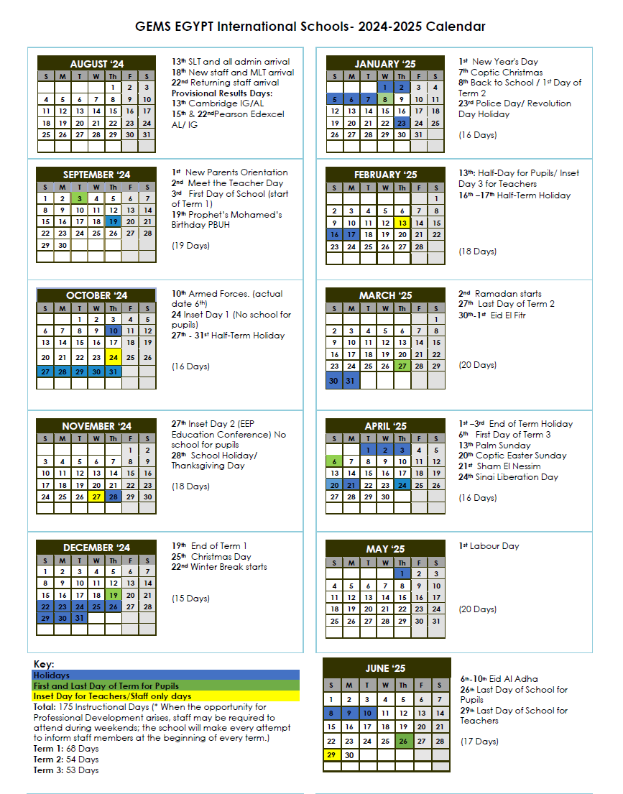

# The School Day, Attendance and Punctuality

**Secondary School Timings**

**Registration**  07:45- 08:00 - Students must arrive at school before 07:45 in order to be punctual for registration, during which they will perform the national anthem.

*Students entering their form room after 07:50 are marked late in the register.*

**The school day**

|  |  |
| --- | --- |
| **Upper school** | |
| **Registration** | **7:45-8:00** |
| **Period 1** | **8:00 - 9:00** |
| **Period 2** | **9:00 - 10:00** |
| **Break** | **10:00 - 10:20** |
| **Period 3** | **10:20 - 11:20** |
| **Period 4** | **11:20-12:20** |
| **Lunch** | **12:20- 13:00** |
| **Period 5** | **13:00 - 14:00** |
| **Period 6** | **14:00 - 15:00** |

**Attendance**

Full attendance whether this is by virtual learning or physically attending school, is vitally important so that your child can benefit fully from their time at school. It is the student’s responsibility to make up for lost time and to catch up with missed work. All lessons and work should be available on phoenix classroom or alternative platforms for some teachers. Parents should avoid making holiday arrangements during term time as this will undoubtedly have a negative effect on their child’s progress.

Parents are asked to inform the school, by phone, on the first day of absence. Failing this, the school will contact parents on the second day of absence. On their return to school, the student must bring a note of explanation, written in the student diary.

*Note: For Year 11 and 12 students only*

*Students must sign in and out through the signing in machine by the Common room whenever they arrive or leave school after 8:00 am.*

**Please note that it is a Ministry of Education requirement that all students must attend 85% of all lessons in order to be accepted for entry to public examinations.**

In our view, if a student misses 15% or more of their education, they will have serious problems catching up with work missed. Although the lesson content is available on phoenix classroom the actual lesson cannot be repeated, and there is no substitute for being present when the teacher introduces the work. Participating in discussions and contributing to question and answer sessions are an essential part of learning. Clearly, if a child is ill, they must stay at home, but this is generally a rare occurrence.

**Punctuality**

As we all know, punctuality is extremely important in a large organisation. Students need to learn self-discipline and how to organise their time efficiently. These are essential skills for later life and for the world of work. In the modern world, poor timekeeping suggests a casual, irresponsible attitude to work and usually results in lost pay. In school it also signals a lack of respect for teachers and students whose work is disrupted by students arriving late. We want our students to build a good reputation for their serious approach to their education and develop habits which they will continue to benefit from in later life.

Students can enter the school through gate 2 from 07:30. Students will stay on the quad from 7:30 till 7:40. Registration starts at 07:05 and students who arrive after 07:50 will be marked late and sanctions may be applied. The Ministry of Education requires all students with Egyptian or dual nationality to attend the playing of the National Anthem at the beginning of the school day and so this will be done during registration every day at 07:55.

If a student is exceptionally late and misses registration when key information is issued for the day, this is more serious. Lessons begin at 08:00 and students arriving after this time must be signed in at reception. Students arriving after 8:00 am might not be allowed into the lessons. The Head of upper school will then be made aware each week of students who have arrived to school late. If a student is late three times after 07:50, sanctions will be imposed. It is important that parents support the school in this and arrange transport to ensure that students arrive in school on time. In case of repetitive tardiness parents will have to sign a declaration form stating that it is their full responsibility to bring students to school on time.

# Essential Classroom Equipment

STUDENT DIARY 4GB flash drive

Scientific calculator Pens

Protractor Pencils

Set Square Ruler

Compass Rubber

Pencil Sharpener Colours

Pencil case Pair of small, in-ear headphones for ICT

Glue Scissors

Students must bring a full set of essential equipment every day. Lost or damaged items must be replaced promptly to avoid causing problems in lessons. The work of a whole group can be adversely affected if a student is without the item required for a particular activity.

The pencil case is vital to keep the equipment together and to keep it clean and in good condition. Good personal organisation is important in school where students have to pack up quickly to move on to the next lesson. It is also a signal that a student values their belongings and knows how important it is to be self-reliant and well-prepared.

# 

# Before School and at Break and Lunchtime - Where should I be?

The next page is addressed to students and tells them where they should be when they are in school.

**Where should I be?**

During the school day, the school is responsible for your safety and, so that the staff can fulfil their responsibilities, we need to know where you are at all times of the day. Your timetable tells you exactly where you will be during normal lesson times but where should you be at other times? The following timetable explains exactly where you should be at these other times of the day.

**Arriving at school**

Students should arrive in school, properly dressed in the correct school uniform, wearing a face mask. Before school, no Secondary students should be in the building unless using the toilets on the ground floor.

07.30 – 07.40 students should enter through gate 2 and remain on the quad

07.45 – 08.00 Students attend morning registration.

**Lunch time**

Students are allocated a position either on the field or in the Quad Area

NB. Some areas are 'out of bounds' ie. forbidden to students. These include:

* the Swimming Pool, unless accompanied by staff for a lesson
* the area behind the stages in hall
* the car parks
* the Primary corridors
* the reception seating area.

Secondary students should not be inside the building unless they are using the toilets, or they have been instructed to keep an appointment with a teacher.

During lesson times, all students should be in classrooms unless they have permission from their teacher.

When moving around the school, students must walk on the left and remain only use the Secondary corridors and stairs.

At the end of the school day, students should leave the site promptly and calmly, still properly dressed in our school uniform. The area around the school is often congested with traffic and parked cars so students must behave sensibly. Acting in a safe and responsible manner and taking care of younger students will contribute to the good reputation of the school.

**Absence**

We are requesting that parents either email, call reception or send a message via phoenix classroom to explain the reason their child isabsent from school. In case of repetitive absence, parents will be asked to sign a declaration form that it is their full responsibility to bring their child to school.

**Homework**

Homework is an essential part of the Secondary curriculum. Students need a quiet place to work with a chair and table but without distractions such as mobile phones, TV, loud music or the internet. Of course, use of the internet is sometimes expected for homework, but parents must monitor this carefully to make sure that students are on task. Parents can see the homework set by checking the phoenix classroom along with the date it is due. They can then help students to plan their time and check that homework is done, ensuring that deadlines are met. Concerns about homework can be raised through phoenix classroom or by sending an email to the tutor or subject teacher.

# Our Positive Achievement Strategy

Rationale

* We all thrive on recognition of our efforts and praise for our successes. Students need this, even more than adults, to motivate them to continue to work hard and conform to our expectations. Of course, the praise must be for a specific reason and the student must feel it is well earned, otherwise it has no value.
* We know that recognizing and rewarding small successes motivates students to work hard. The converse is also true; if we fail to recognize students doing the right thing, they become de-motivated.
* Our school community needs a calm, orderly environment to be able to function effectively. We need clear, unambiguous rules, focused on supporting effective teaching and learning.
* The majority of students will follow the rules and behave responsibly. Some who usually behave well will occasionally push the limits, as part of growing up and need to be redirected. A small minority of students may deliberately choose not to conform to our rules.

**We intend to focus on the desired behaviour and spend our energy on this rather than on the negatives.**

Aims

Rewards should be accessible to all students. Small rewards should be available in every lesson and can lead to greater incentives. We aim to:

* Reward small successes with tangible praise.
* Reward the ‘silent majority’ who regularly do the right thing.
* Reward good work.
* Reward great or improved effort.
* Reward a willingness to help others.
* Provide incentives to sustain the desired behaviour.

Outcomes

We will know the strategy is effective when:

* students know that doing the right thing will be recognised
* more teacher time is spent in positive and productive conversation with students
* students enjoy their success and are motivated to work hard
* teachers deal with troublesome behaviour in a calm, non-confrontational way
* students accept the rules and react appropriately when warnings are given
* poor behaviour in any classroom earns the same response and punishment.

Clear Rules

We expect, insist upon and recognise good behaviour but we have a clear, staged system in place to deal with transgressions.

Individual subject teachers will use class time, at the beginning of the academic year, establishing their ground rules with each teaching group. These discussions should illustrate the links between good organisation, good behaviour and effective learning as well as the responsibilities that each individual has when part of a class or smaller group. Students should be asked about what could go wrong and how that might affect the progress of the group so that they know why sanctions are applied.

Tutors must spend time in discussion with their tutees, going through the rules which apply outside the classroom, identifying why they exist and the consequences if students break them.

We are adopting the slogan BE THE BEST YOU CAN BE as part of emphasising positive achievement. Students will be reminded about our expectations of their behaviour by posters around the school and inside classrooms. Samples of the style and wording are shown below. Our aim is to encourage students to behave in a way that makes them proud of themselves and helps us to run the school efficiently and effectively.

**BE THE BEST YOU CAN BE**

**In the classroom:**

* Arrive on time
* Be clean and tidy
* Bring essential equipment
* Listen actively
* Work hard
* Speak only in English
* Respect others

**In a Test/Exam:**

* Bring all your equipment
* Line up calmly and quietly
* Sit where you are told
* Listen to instructions
* Do not ask for help
* Raise your hand for attention
* Speak only in English
* Respect others

**In the corridor:**

* Walk on the right
* Move quickly and quietly
* Do not stop to chat
* Line up sensibly
* Speak only in English
* Respect others

**At the Kiosk or Dining Hall:**

* Form a queue
* Wait your turn
* Speak politely
* Say please and thank you
* Put your litter in the bin
* No food or drink orders after the whistle

**In the Quad Area:**

* No running
* No shouting
* Move on the whistle
* Speak only in English
* Respect others

**On the Field:**

* No food or drink
* Play fair
* No dangerous play
* Do not exclude others
* Move on the whistle
* Speak only in English
* Respect others

**On the Basketball Courts:**

* No food or drink
* Play fair
* No dangerous play
* Do not exclude others
* Move on the whistle
* Speak only in English
* Respect others

**Rewarding success**

Teachers will have their own ideas about recognising success. These are likely to include:

* Appropriate verbal praise; praise in front of peers.
* Using work or behaviour as an example for others to follow.
* Positive written comments on work, stickers.
* Student sent to show work to a colleague, tutor, Head of Department, Head of School or Principal.
* Using work for display.
* Giving the student a responsibility - class ambassador, monitor etc.
* Invite a member of SLT to see the class at work.
* Points awarded.
* Commendation/Award certificate.
* Greeting and showing visitors around school.
* Representing the school on a public occasion.
* Good comment on end of year report.
* A letter home.

The tangible evidence of our recognition will be points, House Points and prizes. At the end of the year we also award prizes for 100% attendance.

**Sanctions**

For those students who push the boundaries of behaviour in school we have a staged system of sanctions.

If the usual advice, stern looks and warnings have been ignored, sanctions might involve: formal warnings, break detentions, lunchtime detentions, after school detentions or suspensions. Throughout the process, the tutor and parents are kept informed through the student diary, phone calls, meetings and letters.

**Monitoring**

We may decide to monitor a particular student’s behaviour through a Tutor or SLT Report or in extreme cases, a Principal’s Report. This gives the student an opportunity to show how well they can work and behave.

**Secondary Positive Behaviour & Achievement Strategy**

**EXPECTATIONS WITH REGARD TO PUPILS**

Pupils will be expected to:

* conduct themselves around the building in a safe, sensible, manner and show regard to others
* arrive on time to lessons, ready to learn with the correct materials and equipment
* follow reasonable instructions given by the teacher
* behave in a reasonable and polite manner to all staff and pupils
* complete all class work and homework in the manner required
* show respect for the working environment
* follow the school rules (e.g. uniform, no chewing, one ball rule etc)
* speak English only inside the school building (apart from Arabic or French lessons).

**Rewards:**

* Certificates
* Prizes
* trip/activity day.

**Sanctions:**

**Year 9 students will be following the lower school behaviour policy:**

**Year 10 to 12 are to be subjected to the below sanctions:**

1st step – behaviour noted by an incident report

2nd step – behaviour noted by an incident report and Lunch-time detention issued for next day

3rd step – behaviour noted by an incident report and two Lunch-time detention issued for next two days plus possibility of not allowing students on trips

4th step – meeting with parents to discuss behaviour and set targets on individual report

5th step – isolation

6th step – Suspension; based on MOE rules

Minor incidents – step 1,2,3&4

Major incidents – Step 4,5&6 (only through pastoral team)

Note: Both positive and negative behaviours will be recorded on Phoenix along with your house points.

**Assessment**

As you are aware, in the British education system, we regularly assess students to establish what they have learned and to help teachers to plan future learning opportunities. We train students from Year 6 to prepare well for tests and exams, to bring the correct equipment in a clear plastic bag, to be honest and to follow the rules which are the same for all. Sanctions will be applied if the rules are broken.

Assessment will take place in a number of different forms. This may be tests, project-work or an on-going extended piece of writing. Students are assessed using a range of criteria relating to skills, knowledge and understanding in each subject. At Key Stage 4 and5 , students will receive an attainment grade for each assessment that is also linked to a threshold. The table below shows the grades that we use.

|  |  |
| --- | --- |
| **Grade** | **Threshold** |
| **A*or 8,9** | Exceptional Performance |
| **A or 7** | Working **beyond** expected level |
| **B or 5,6** |
| **C or 4** | Working **at** expected level |
| **D or 3** | Working **towards** expected level |
| **E or 2** |
| **F or 1** | Working **below** expected level |
| **G or 1** |

# Mobile Phones

Mobile phones are not allowed to be used in school. If a child wishes to bring a mobile to school it should be handed to the form tutor in the morning and collected at the end of the day. Parents who need to relay an urgent message to a student can do so by calling reception. Students who need to relay an urgent message to a parent can ask for permission to call home.

**As a general rule, if mobiles phones are seen or heard, they will be confiscated,** **and parents will be required to collect them from reception at the end of the next working day. If the incident is repeated the mobile phone will be confiscated for a whole week and to be returned the parents at the end of the seven days period.**

**In case of repetition, the phone is to be confiscated till the end of the term.**

# Extra-Curricular Activities

The Secondary School ECA programme operates after school until 16.00, on Mondays and Wednesdays. The students are given a choice of activities. These have previously included football, basketball, cricket, softball, tennis, table-tennis, cooking, jewellery making, painting and mask making. Students select a new activity at the start of each term. The purpose is to broaden their learning experience and have fun but of course punctuality, dress code and commitment are still very important.

# Driving motorised vehicles to school

We understand that there are laws and age requirements governing the licensing of drivers and that none of our students are currently eligible for this. We expect students and families to comply with the law, particularly when the students are in our school uniform.

We have made it clear to students at BISM that it is forbidden to drive a motorised vehicle to or from school or near the school. It is also forbidden to drive anywhere on school business or to drive while wearing our school uniform. The school cannot be associated with law breaking.

If students ignore the school rule and the law, we regret that we will have to suspend their place at The British International School, Madinaty.

If your son or daughter reaches the age of 18 and you wish them to drive to school, please provide us with a photocopy of their valid driving license and a letter from you saying you give them permission to drive and that you take full responsibility for any injury or damage caused by vehicle or driver.

# Behaviour on School Buses

Orderly conduct on school transport is essential both for the safety of the students and for the good reputation of the school.

**For travel between home and school**, the school assigns a supervisor to each bus and it is their responsibility to ensure that all students behave in a sensible manner.

The bus supervisor will assign a seat to each student. Students must remain seated, wearing their seat belt for the duration of the journey. Students must cooperate with the supervisor, driver and any other adult on the bus, speak politely and avoid shouting or otherwise annoying other passengers. In particular, for safety reasons, students must not lie across the seats or open windows without permission. Litter must be taken home.

Should any student misbehave in any way, the incident will be reported, in writing, to the school by the bus supervisor. Repeated or serious incidents will result in bus privileges being withdrawn on a temporary or permanent basis. Students will be made clear of the terms of using the bus at the beginning of the year.

**Disciplinary procedure for misbehaviour on school transport (to and from school)**

**First Incident:** The bus supervisor records the incident and sends the report to the transport manager.The report is translated and logged and sent to the Tutor and Principal who will then meet the student.The incident is discussed with the student and a warning is written in the diary to inform parents.

**Second Incident:** The same process above is repeated with a Yellow letter of warning being sent home in the diary to inform parents, a further complaint will result in a ban from the bus. Some further sanctions may be applied by the school to deter a repeat of this behaviour such as a ban from a house competition or school trip.

**Third Incident:** On receipt of a third complaint, the Principal will issue a standard letter to parents, **withdrawing the pupil from school transport for 5 school days**; a copy is sent to the Transport Manager, via reception.

**Any further incident will cause the student to be withdrawn from school transport for the rest of the term and may result in a permanent ban.**

Should a student be involved in a very serious incident on a school bus, they may have school transport withdrawn permanently.

**For travel between pick up points and school or on a school trip,** thesame high standards of behaviour are expected. Misbehaviour on the bus will attract the same sanctions as misbehaviour in lessons. Dangerous behaviour, or behaviour likely to have an adverse effect on the school’s reputation, could result in a ban from attending school trips or events that require transportation.

# Bullying

*The following is a part of our Anti-bullying policy:*

We believe that all forms of bullying among adults or children are anti-social, unacceptable and wrong. We must respond to all instances of bullying. Incidents must be brought out into the open so they can be discussed and strategies agreed to help resolve the problem. If we don’t talk about bullying, we support the bullies.

#### What is Bullying?

Bullying is not the same as 'falling out with friends' or the small frictions which occur as young people mingle. Rather it is targeted, usually repeated, sometimes persistent behaviour intended to hurt someone physically or emotionally. Bullying is about power. Those being bullied feel powerless to stop it.

*Children mirror the behaviour they receive. So, to combat bullying we need emotionally literate and aware adults to show children, by example, how to treat each other with respect, tolerance and care.*

  [After J C Piech 24.03.13]

Bullying can involve race, colour, religion, nationality, gender, special educational needs and can take many forms including:

1. Physical: e.g. hitting, kicking, taking or hiding belongings.

2. Verbal: e.g. name calling, teasing, insulting, writing unkind notes or emails.

3. Emotional: e.g. spreading rumours, excluding from groups, tormenting, staring.

4. A combination of the above: e.g. extortion (forcing someone to give up money or belongings) or intimidation (making someone frightened because of threats).

5. Cyber bullying eg. by mobile phone, messaging services, social networks, internet.

**Signs of Bullying:**

Parents and teachers have a responsibility to investigate signs of distress in pupils as well as responding to reports of bullying. The following types of behaviour may be symptomatic of bullying:

a) obvious signs of distress such as tearfulness or a constantly miserable expression

b) an unwillingness to come to school

c) frequent headaches, stomach aches or complaints of feeling generally unwell

d) demands for money

e) physical signs (bruises etc)

f) isolation from other children

g) a sudden deterioration in standards of work

h) a reluctance to leave the classroom at the end of the lessons or at the end of the school day

i) a tendency to stay close to staff during breaks

j) damage to student property

k) uncharacteristic behaviour

**Bullies and targets**

Any one might be a target for a bully but the characteristics or experience of some children may make it more likely that they will bully or be bullied. Some may be both bully and someone who is bullied. It is important to involve all those involved in an incident when seeking a solution, silent witnesses too.

Potential bullies may:

* display anti-social/poor behaviour, intrusiveness or a tendency to spread gossip
* be arrogant
* be large or small for their age
* be physically stronger
* underachieve
* be targets of bullying by parents/siblings/relatives

Potential targets may:

* lack close friends
* be shy
* have an over-protective family environment
* belong to a minority ethnic group
* have a disability
* have special educational needs
* not speak Arabic

**Assertiveness Guidance/Training**

We can help potential victims/bullied pupils to develop greater range of skills and responses when caring for themselves. Children can develop the confidence to take control of situations using responses which “de-escalate” conflicts. When bullied pupils use these strategies, they can reduce the risk of future bullying.

**Encourage students to tell about bullying.**

It is important that we create an atmosphere in school where anyone who is being bullied, or others who know about it, feel that they will be listened to, and that action taken will be swift and sensitive to their needs. Telling an adult can be direct and open or indirect and anonymous. Everyone must realise that not telling supports the bully. There are often several groups involved in an instance of bullying, the target, the bully, the friends of the bully who may take an active part and the silent observers.

**Action**

We treat all reports of bullying seriously and will involve the target, the bully and the observers in a discussion process to seek a solution which helps avoid future bullying. Where the incidents are persistent or cause serious harm, we will involve parents in the process.

# The British International School Uniform

All students are expected to wear the school uniform purchased from the designated shop. Most items will show the BISM logo. Photographs can be seen on the website [www.bism-cairo.com](http://www.bism-cairo.com). The uniform must be clean, ironed and of a suitable size and length; skirts and skorts must be worn on the waist and reach the knees. Shirts must be tucked in.

If a student cannot wear an item of uniform on a particular day, parents should explain this to the tutor via an email, the parent has to contact PRE in case of unavailability of the uniform in the store.

If repeated, the parent has to come to sign a declaration form.

If repeated, the student can be suspended for up to 3 days.

NB. Jeans are never acceptable in school.

No jewellery is permitted except a small pair of earrings and a watch. Long hair should be off the face and tied back if necessary.

Seniors are allowed to wear senior shirts and jackets provided that they have school pants on.

**Lost and Found**

Everyone loses things now and then. When students lose something, they can look for it in the Lost and Found. When students find something that belongs to someone else, they can take it to the Lost and Found.

1. Putting your name and form on your jackets, sweaters, and other personal possessions will make it easy to find them and return them to you in case you lose them.

2. Items that you don't need for school, especially valuable ones, are best left at home.

3.Check for your lost item in the last place you had it. Perhaps it's in the classroom you were just in, so check around your seat and ask the teacher.

If you don't find it, check the Lost and Found. Check once right away. If you don't find it there, check again later or in a day or two because somebody might have found it and turned it in.

4. If still not found, inform your form tutor

# Who should parents contact in the secondary school?

* If the matter relates to a particular subject, parents should contact the subject teacher. If the matter remains unresolved, they should then speak to the the head of key stage.
* For all other matters, parents should contact the tutor. If this matter remains unresolved, parents should contact Key stage heads.
* On the rare occasions that the enquiry has still not been satisfactorily answered, parents should be referred to Dr. Samantha Daisley, Head of Secondary.

|  |
| --- |
| **Home-School Agreement** |
| **The aim of our Home-School agreement is to make clear to parent/carers, students and staff that they all have an equal part in developing successful young adults.  The success of each student will be built upon a mutual and supportive partnership between home and school.**  **We ask that you carefully read the agreement below and the behaviour policy with your child.** |
| **Pupils are expected to:**     * have a positive work ethic and meet all deadlines. * Enter classes, quietly and with a readiness to work. * behave correctly to promote a positive image of the school in the community. * act as a role model to younger students. * wear the correct school uniform. * arrive to every lesson fully equipped. * arrive punctually to registration and lessons. * Move through the school sensibly and with the minimum amount of noise so as not to disturb other classes. * be respectful, polite and courteous to all members of the school and community. * Respect other people beliefs. * take responsibility for their actions. * respect the property of the school and others. * arrive punctually to registration and lessons * wear the correct school uniform * hand all correspondence to parents on the day of issue (envelops addressed to parents should not be opened. * use English (except during Arabic and French lessons) while on the school premises (including the buses) as a means of inclusion. * ensure that mobile phones are turned off and are not used during the school day. * never use any device to record or photograph others without their permission.     **Students signature:_____________________________________   Date:________________** |

# Study Skills

# The following information is a guide to help students study and revise throughout their IGCSE courses. Your child’s teacher will provide help and advice about how to study and revise in their particular subject in order for students to be as best prepared as possible by the time they reach the end of Key Stage 4. There will be opportunities for you to discuss your child’s progress at Parents’ Evenings and you will be informed by your child’s teacher if there are any issues or concerns, though please do not hesitate to contact us if you have any questions.

# The following study tips are aimed at IGCSE students to help them study and revise for tests and examinations:

* Remember, by the end of your IGCSE courses in year 10, you will have to sit for the external exams from the British council
* In order to revise this properly, you need to start revising early and in an organised manner.
* One way to start is by collecting the syllabus for each of you subjects (available in this handbook).
* Once you have the syllabus for each subject, a good way of prioritising your revision is to use a traffic light system. Basically this means choosing three highlighters (red, yellow and green are good ones to use). Highlight the content that you have difficulty with in red, the things that you need some help with in yellow and the content that you are happy with, in green. Below is an example of how you might do this.

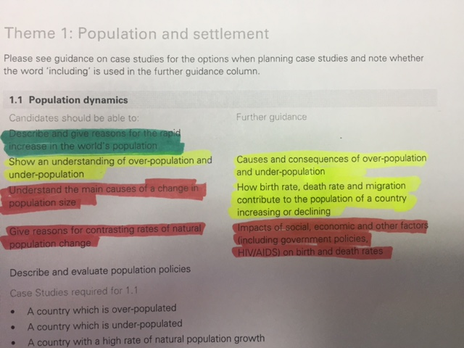

* Once you have gone through each syllabus, you can then write/copy & paste the points you have highlighted in red onto one sheet so that you know which topics you need to focus on for each subject.
* You are now ready to revise!
* There are a number of different ways to revise. Look at the ideas below and find out which ones are best for you. However, you shouldn’t just read through your notes/textbooks as you are unlikely to retain any of the information this way.
* **Making notes of the key words/concepts**: you can write these notes on cards so you can easily review them. You could also write them on post-it notes and place them around your house in rooms that you go in frequently (e.g. your bedroom, on the fridge etc).
* **Mind Maps** – these can help summarise a topic on one page so that you can view everything easily. Below is an example of a mind map for History.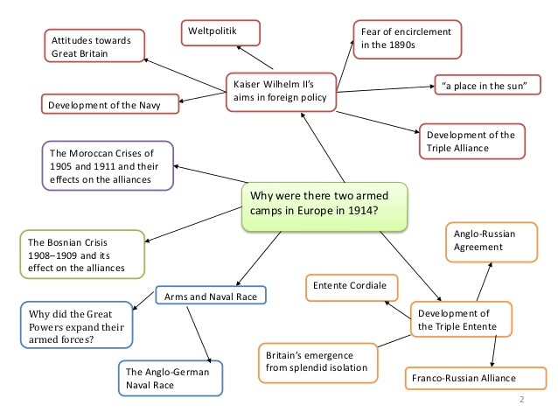
* **Past papers**: answering past papers is another good way of revising as you also get to practise the types of questions that may come up in your exam. Try to answer some past papers under timed conditions so that you practise answering the questions in the same amount of time that you will have in the actual exam.
* **Revise with a friend**: by doing this, you may help each other with some concepts that you’re having difficulty with and you can also test each other. However, be careful not to get distracted & talk about other things!
* **Talk to your teachers** – teachers are there to help you! Don’t be afraid to speak to your teachers to ask for help with anything that you are finding difficult.

|  |  |  |  |  |  |
| --- | --- | --- | --- | --- | --- |
| **Suggested Times** | **Sunday** | **Monday** | **Tuesday** | **Wednesday** | **Thursday** |
| **18:00 – 19:00** | Maths | Geography | Physics | ICT | Maths |
| **19:15 – 20:15** | French | Business | Economics | Biology | Geography |
| **20:30 – 21:00** | History | Chemistry | Computer Science | English | Chemistry |

Closer to your examinations, you should draw up a revision timetable so that you can revise in an organised manner. Below is an example of a revision timetable.

**Other useful hints and tips:**

* Revise in a quiet place to avoid any distractions.
* Switch off all social media/notifications or any other unnecessary distractions.
* Make sure you eat well and take regular breaks.
* Go to bed early and get a good night’s sleep the night before a test or examination.
* Take one night off a week to do something that you enjoy. This will help you refocus.

# Curriculum

**IGCSE & A Level Programme of Study**

* In Year 9, students will begin the first year of their IGCSE courses in the core subjects of English, Maths and the three Sciences (pre IG).
* In addition to this, they will also take lessons in Computing, Humanities, French, Art and Business during Year 9 when they are not studying their IGCSE courses. This will help with continuity of these subjects if they decide to choose them for IGCSE in Year 10.
* Year 9 students will sit the external PRE-IGCSE’s (CIE) in English, Maths and Science at the end of the academic year.
* In Year 10, students will follow their options schedule and sit for exams in June 2025
* In Year 11 they will have the opportunity to take AS levels as long as they have had at least 6 in the relevant IGCSE subject.
* At the end of Year 11, they will sit their final IGCSE examinations in their non-core subjects, as well as any AS levels that they have chosen to study.
* In Year 12, they could then complete full A levels in the subjects thy started at AS in Year 11, as well as doing some AS levels in other subjects (Business, French etc).
* Students could also have the option of just concentrating on their non-core l IGCSE subjects in Year 11 and then taking AS Levels in Year 12, depending in their university entry requirements (see below).

One of the main advantages of this revised programme is that students will no longer sit the final examinations for all eight IGCSE subjects in one examination session. Rather, they will sit final examinations in up to five subjects at the end of Year 10 and the rest will be taken at the end of Year 11.

Should you have any further questions about this, please do not hesitate to contact me.

***Options blocks:***

*Students can choose one subject from each block. Option blocks are to be chosen with head of upper school as per the options form announced time during the year. Two forms are emailed to parents; initial one in November and a final one in February for the students to choose their options.*

***In case of any required changes the announced deadlines, parents need to email head of upper school/ head of secondary/ exams office requesting the change. Approval is pending availability, subject teacher approval and is subjected to penalties application.***

*Please note that English and Maths are obligatory in year 10.*

*Please note that MOE subjects are obligatory.*

**IGCSE November session exams policy:**

Students are allowed to take subjects externally under the following conditions:

1. The student is in year 10 going to 11 or in year 11 going to 12.

2. The student has a proven record of excellent exam results (not less than A across all subjects in mock exams and June exams session)

3. The student has registered at least 3 other IGCSE or AS/A2 subjects for the June session of the same academic year through the school.

In case of approval by head teachers, **the student is to pay subject fees of only 10 thousand Egyptian pounds instead of the normal subject fees to the school in addition to the normal exam registration fees By Aug. 1st, 2024.**

**External subject policy:**

Students who wish to register for external subjects not provided in the school can only do so in year 12, provided they have excellent proven subject results across years 11 and 12.

In case of approval by head teachers, the student is to pay subject fees of only 10 thousand Egyptian pounds instead of the normal subject fees to the school in addition to the normal exam registration fees.

**The penalty for withdrawal from registered subjects in the options:**

After 2 weeks from the start of September of the academic year: No penalty fees applied

After 3 weeks: 10 percent penalty of the subject fees

After 4 weeks: 25 percent of the subject fees

After 6 weeks: 50 percent of the subject fees

After 8 weeks: 75 percent of the subject fees

After 10 weeks:100 percent of the subject fees

**Attending in-school courses for resit sessions:**

If a student wishes to attend a course for a resit session in school, the student is to pay only 50 percent of the subject fees, in addition to normal exam registration fees.

It is important to check each syllabus regularly to ensure that you are aware of all of the subject content. Students will be given the syllabus for each subject by their teachers and you can find each IGCSE syllabus on the CIE/Edxecel websites at the addresses below**.**

<http://www.cie.org.uk/programmes-and-qualifications/cambridge-secondary-2/cambridge-igcse/subjects/>

<https://qualifications.pearson.com/en/qualifications/edexcel-international-gcses-and-edexcel-certificates.html>

<https://qualifications.pearson.com/en/qualifications/edexcel-international-lower-secondary-curriculum.html>

# More about the courses you child will undertake along with a detailed curriculum plan can be found on phoenix classroom.