**British International School Madinaty Home Learning Policy**

|  |  |  |  |  |
| --- | --- | --- | --- | --- |
| **Policy** | **Home Learning Policy** | | | |
| **Approval Date:** | August 2024 | | **Next review:** | August 2025 |
| **Review Cycle:** | 1 Year | | | |
| **Scope** | **Whole Group** | ☐ |  | |
| **Primary** |  |
| **Secondary** | ☐ |
| **Ownership:** | PLT | | **Approved by:** | PLT |

**CONTENTS**

**Rationale** 3

**Purpose** 3

**Platform** 3

**Allocation** 3

**Early Years** 3

**Year 1** 4

**Years 2 to 5** 4

**Spellings Home Learning** 5

**IXL (All Years)** 5

**French** 5

**Arabic** 5

**Monitoring** 5

**Version History** 6

# **Rationale**

Here in BISM, we see homework as a process which must ultimately benefit each child in our school.

Homework at all stages should give parents and carers the opportunity to become actively involved in their children’s learning. It is also our intention that homework will encourage greater responsibility and independent learning. As children get older, it will help them organise themselves and their time.

We recognise the key role that family time has to play in the development of our children and we want to make sure that homework does not impinge on this. However, it is really important that parents support with the home learning that is set and talk to their child about their learning daily.

# **Purpose**

This policy has developed in line with the BISM behaviour policy, the Vision, Mission and Core Values which were developed by parents, teachers and students at the school. The policy aims to,

1. Foster and enhance the home/school partnership
2. Provide opportunities for parents to become more involved in their own child’s learning
3. Encourage greater independent learning, and a desire to learn to amazing levels
4. Reinforce and enhance key skills, including challenge for more able children and essential reinforcement for children with additional educational needs
5. Raise overall standards of achievement
6. Provide a consistent whole school approach to homework
7. Provide all children and parents with clear knowledge and understanding of school expectations
8. Improve the overall quality of children’s learning
9. Help parents and children work together in enjoying their learning
10. Help children develop their own learning strategies
11. Enable children to value and appreciate the wonderful gifts and experiences reading and words can provide
12. In KS2, to become mature and experienced in a homework routine to help prepare the children for the transfer to secondary school.

# **Platform**

**ALL homework will be shared via the VLE Phoenix Classroom, not on Class Dojo.**

# **Allocation**

# **Early Years**

At the teacher’s discretion

Phonics Shed Activities

BIG CAT Reading if appropriate

# **Year 1**

Homework will be allocated weekly on a Thursday, with a deadline for the following Tuesday

All Marks to be recorded on a TAB in the teacher Assessment File. The home learning will be allocated from the CGP Books and will include

* 1 Mental Maths Exercise

1 Science Exercise

1 SPAG Exercise

*(Maths, SPAG and science will be allocated in rotation and will amount to between 2 to 4 pages, all classes will allocate the same)*

* Big Cat online reading
* Big Cat physical books (1 per week) *Reading diary to be signed, no books to be changed until reading log is signed *for some children this may mean that a teacher or LSA signs the log as some children’s parents may not be active partners in their children’s learning.

**(New books will be not allocated if an old book is not returned)**

* Phonics Shed Activities on the Learning Platform

LSAs may mark the CGP Books, but are required to feedback the results for teacher input into the assessment tracker. It is the teacher’s responsibility to use the data to inform planning.

**No other home learning may be allocated without the express permission from the Head of Year**

# **Years 2 to 5**

Homework will be allocated weekly on a Wednesday, with a deadline for the following Sunday

All marks to be recorded on a TAB in the teacher Assessment File. The home learning will be allocated from the CGP Books and will include

* 1 Times Tables Exercise
* 1 Mental Maths Exercise
* 1 Science Exercise
* 1 SPAG Exercise

*(1 to 2 pages will be allocated from each book, all classes will allocate the same)*

* Big Cat online reading
* Big Cat physical books (1or 2 per week) *Reading diary to be signed, no books to be changed until reading log is signed *for some children this may mean that a teacher or LSA signs the log as some children’s parents may not be active partners in their children’s learning.

**(New books will be not allocated if an old book is not returned)**

LSAs may mark the CGP Books but are required to feedback the results for teacher input into the assessment tracker. It is the teacher’s responsibility to use the data to inform planning.

# **Spellings Home Learning**

The spellings home learning will be allocated on every Sunday on the VLE Phoenix Classroom and will include

* The spelling list of 10 words
* LSCWC
* Handwriting Exercise
* A word search

*This will not be marked by the teacher or LSA, it is purely practice work

The spelling test will be conducted on the last day of the week, during the allocated slot and the results will be recorded in the teacher assessment file under the correct tab on a weekly basis.

# **IXL (All Years)**

Access to home learning activities will be sent to parents on a weekly basis, for activities that correspond to the taught lessons, with a maximum of three activities per subject.

# **French**

Up to one exercise may be sent per week to those classes who take French, this will be shared on the VLE Phoenix Classroom

# **Arabic**

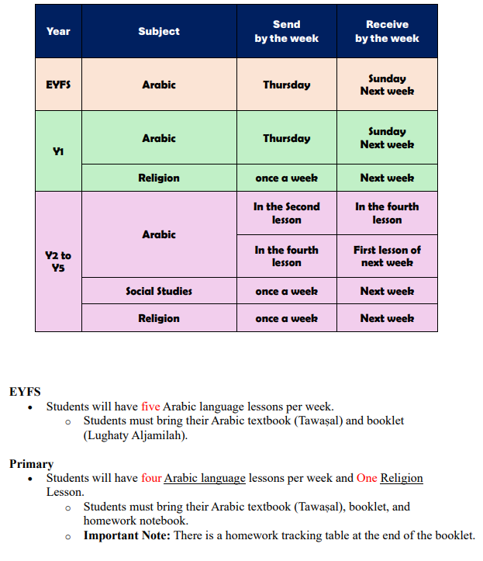

**No other subjects will send homework without the express permission of the Head of Year**

# **Monitoring**

Home learning completion should be regularly scrutinised, and parents to be informed immediately via the behaviour tracker on the VLE if the homework is not completed.

Heads of Year are responsible to ensure the home learning is sent out according to the policy and tracked accordingly in the above subjects for the children in their year group, this includes Arabic and French.

Heads of Year are responsible for ensuring teachers are informing parents of non-completion of homework via the behaviour tracker on the VLE.

**Version History**

|  |  |  |  |
| --- | --- | --- | --- |
| **VERSION** | **ACTION** | **RESPONSIBLE** | **DATE** |
| 1.1 | Policy approved by PLT | PLT | August 2024 |
|  |  |  |  |
|  |  |  |  |